enter year & model
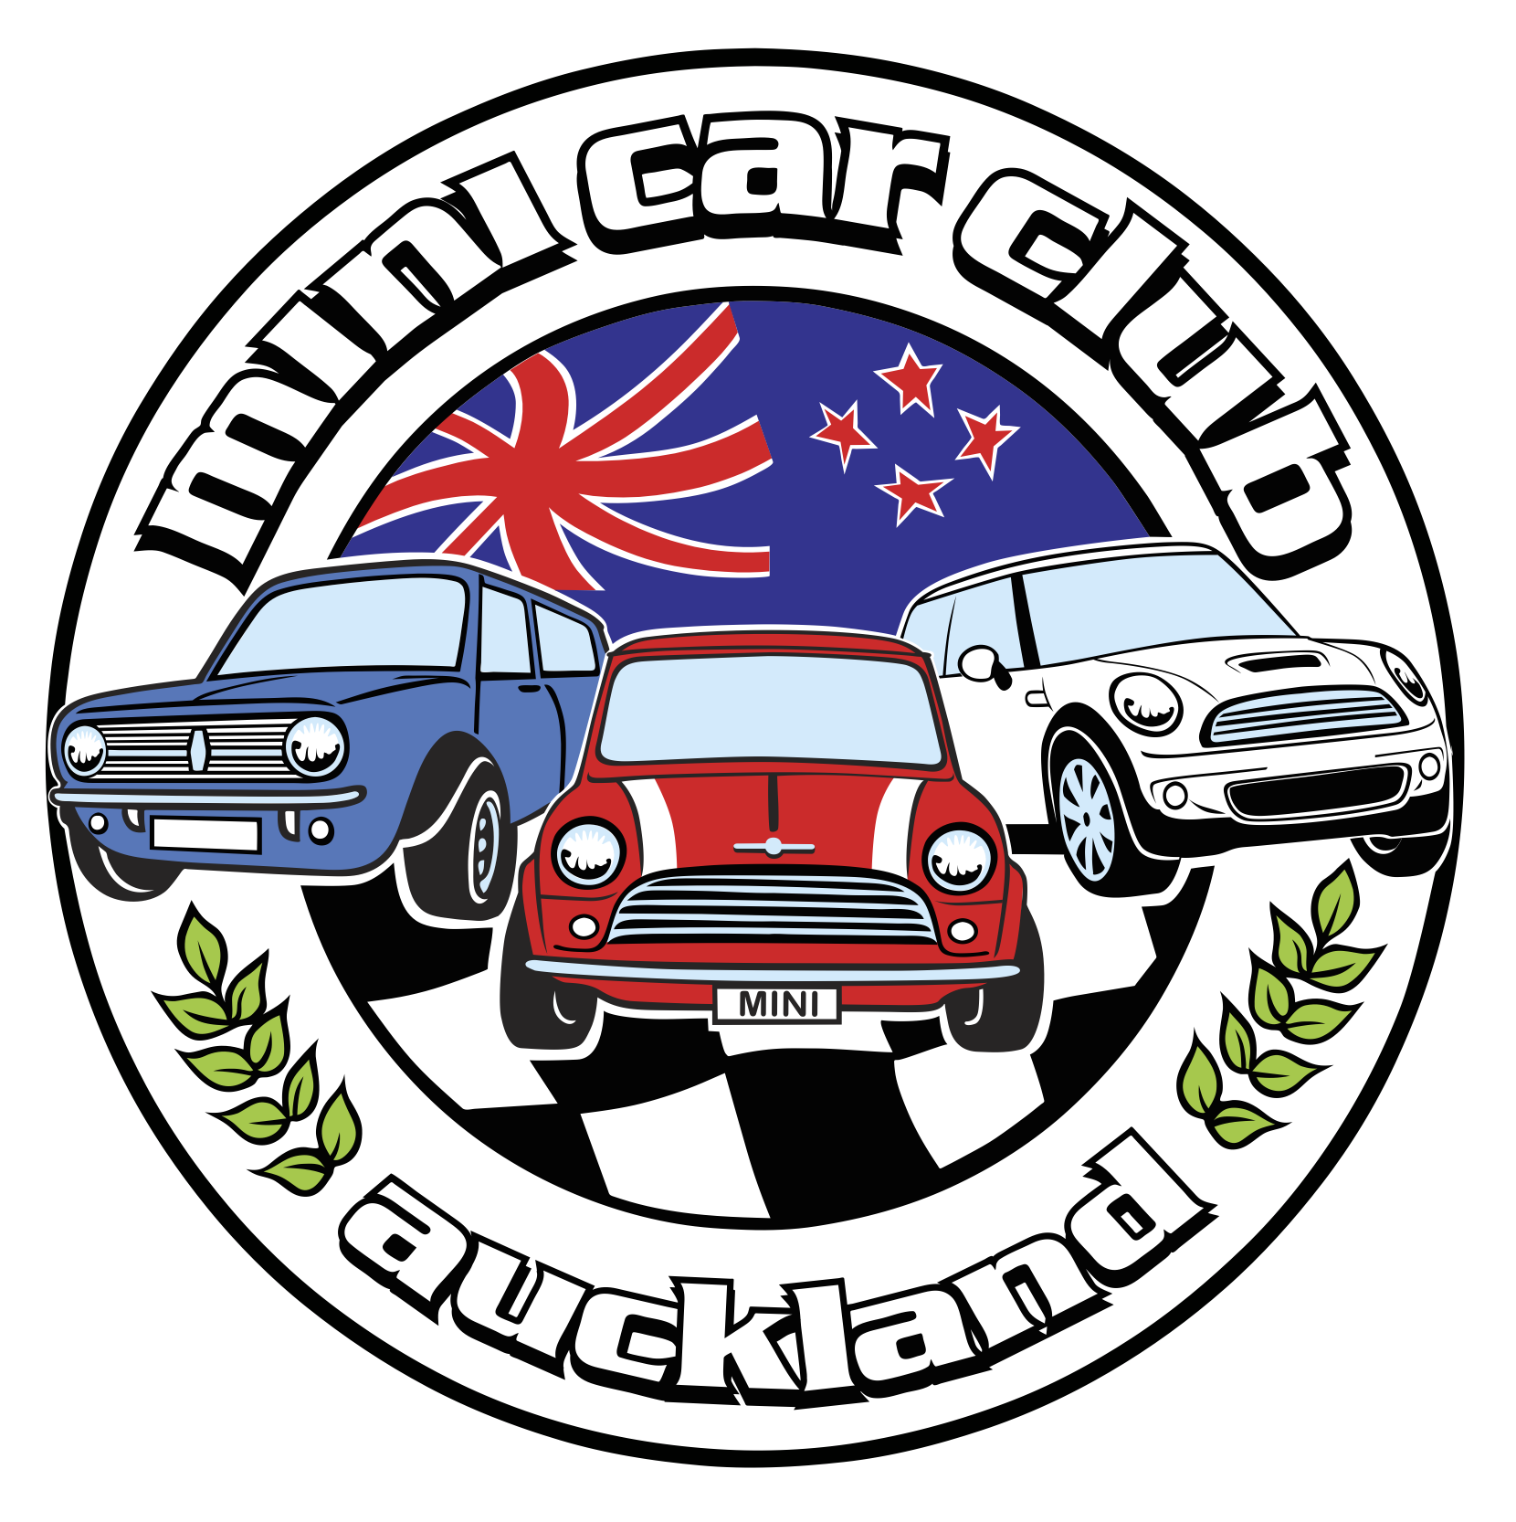

HISTORY
- (example) New Zealand New in 1961

EXTERIOR/BODY SHELL
- (example) British Racing Green & white roof
- (example) Mags and Flares

ENGINE
- (enter engine size) 1275cc engine

GEARBOX
- (example) Front wheel drive
- (example) 4 speed manual

BRAKES
- (example) Drum front and Rear

SUSPENSION
- (example) Cone

WHEELS & TYRES
- (example) 10x6” ROH mags
- (example) 165/70/10 Bridgestones

INTERIOR
- (example) Mini standard seats and trimmings
- (example) Mini Steering wheel

